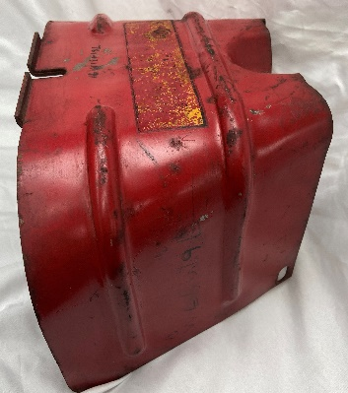
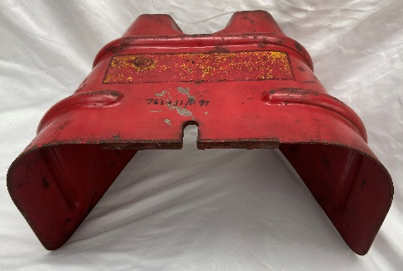
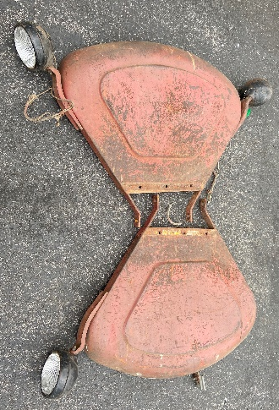
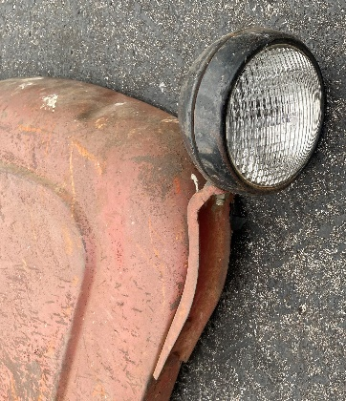

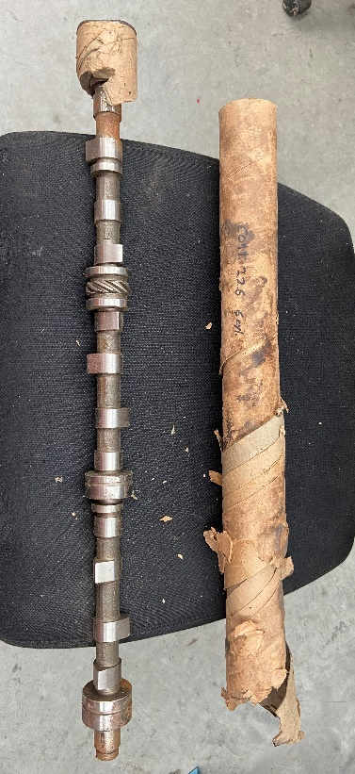
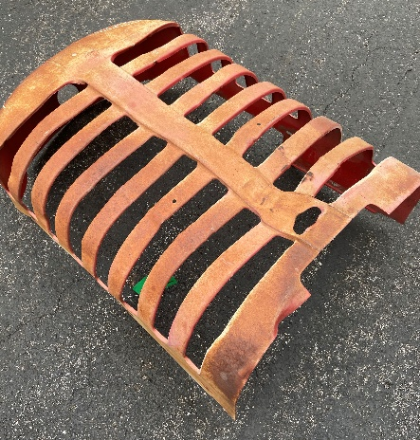
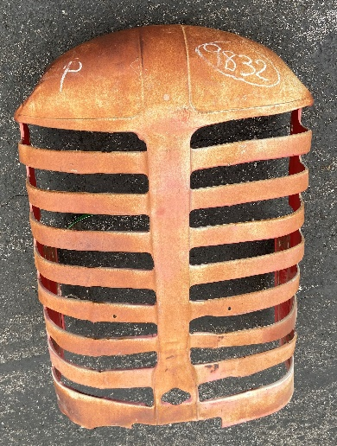
Complete set of fenders with original lights and brackets. One small dent on top. No rust!

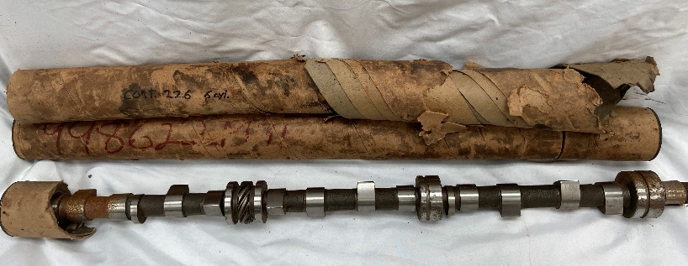
Nice MH 44 grill. Small push-in above crank hole.
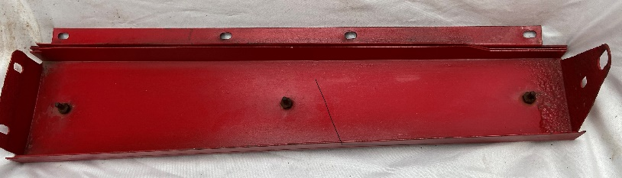
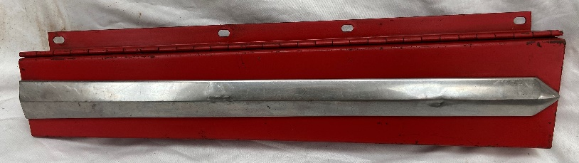
TWO (2) NOS Continental 226 CI 6-cylinder cam shafts!!
Very nice MHF 50 center grill section with Chrome Strip!
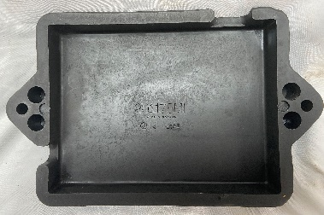
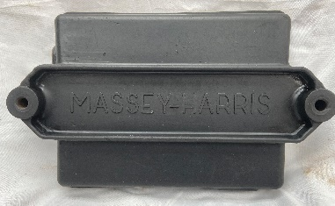
Straight very nice PTO shield
MH 35 Combine Battery Cover. No Cracks.
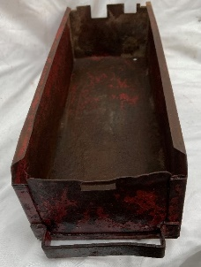
Great Collectible!!
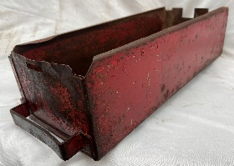
MH Tool Box w/ mounting bracket. Straight. Everything you need.

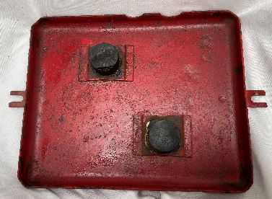
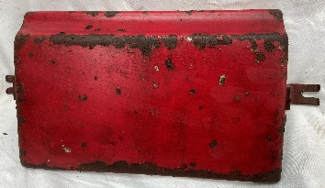
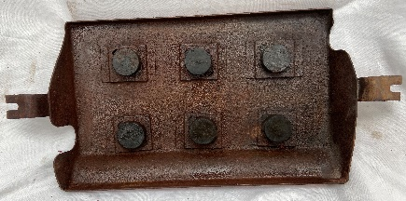
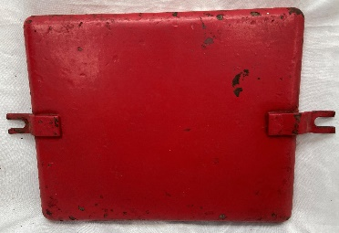
2 Different MH Battery Covers.

Cleaning the shop! No reasonable offer will be refused. First come/first served!! Can deliver to Arcola. IL this week at MCA ASM or Indiana MCA Spring Meeting in Edinburgh, IN April 2. Can also ship at your expense!

CALL or EMAIL: Gary Emsweller
317-554-7237 garye25258@aol.com

MH 44 Hood. Very good shape. Small depression behind radiator fill.
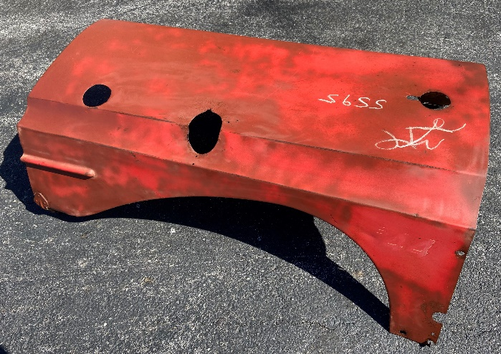

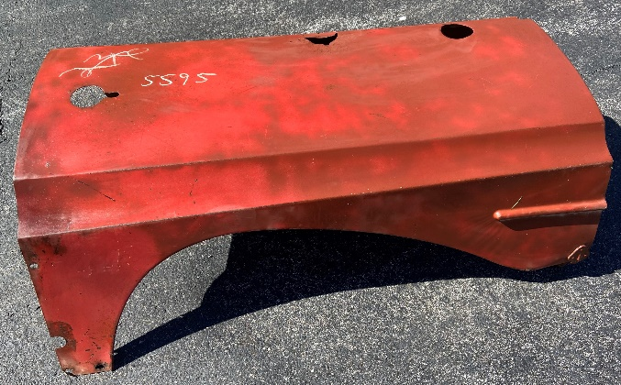

Excellent gas tank with mounting brackets, sediment bowl and cap.
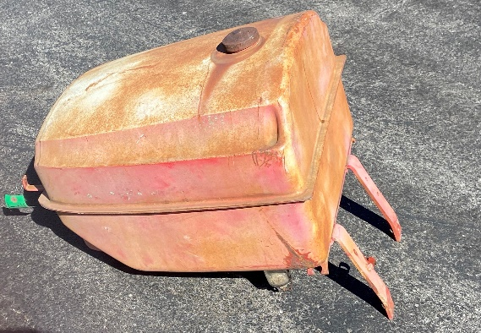

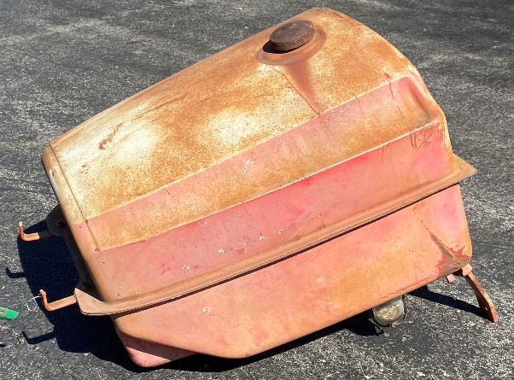

Second MH 44 Hood. Some surface rust but straight.
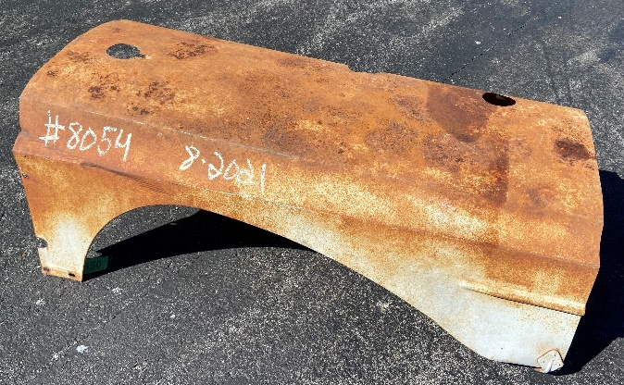

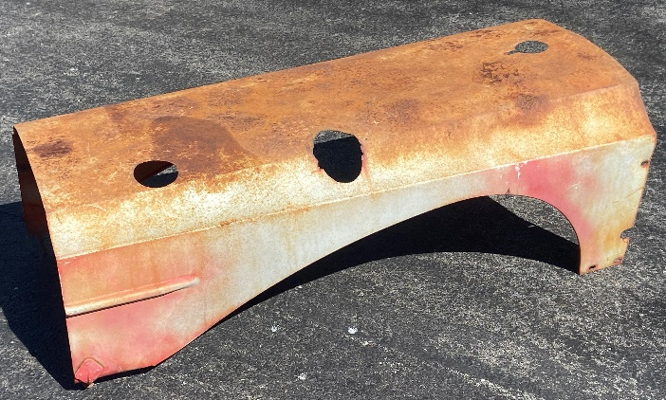

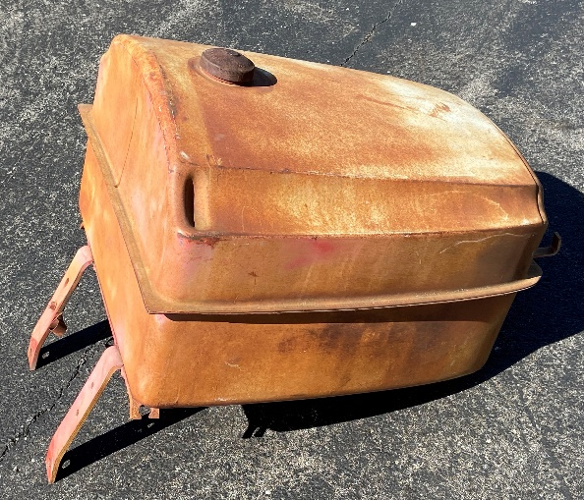

Cleaning the shop! No reasonable offer will be refused. First come/first served!! Can deliver to Arcola. IL this week at MCA ASM or Indiana MCA Spring Meeting in Edinburgh, IN April 2. Can also ship at your expense!

CALL or EMAIL: Gary Emsweller
317-554-7237 garye25258@aol.com

