Carrington Rally Steam & Heritage Show
26th and 27th May 2024.
Boston, Lincolnshire. England.
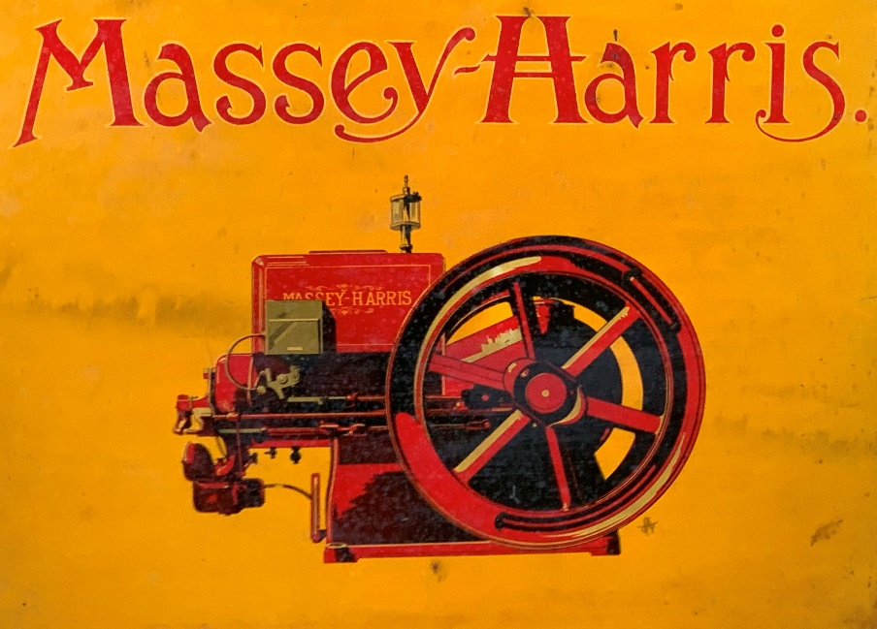
Featuring the 100th Anniversary of the Massey-Harris
“Type 2” Kerosene Engine with High Tension Ignition. Manufactured in four sizes from 1.5 to 6 HP.
