**The 100th Anniversary Of The Massey – Harris**

**“Type 2” Stationary Engine.**

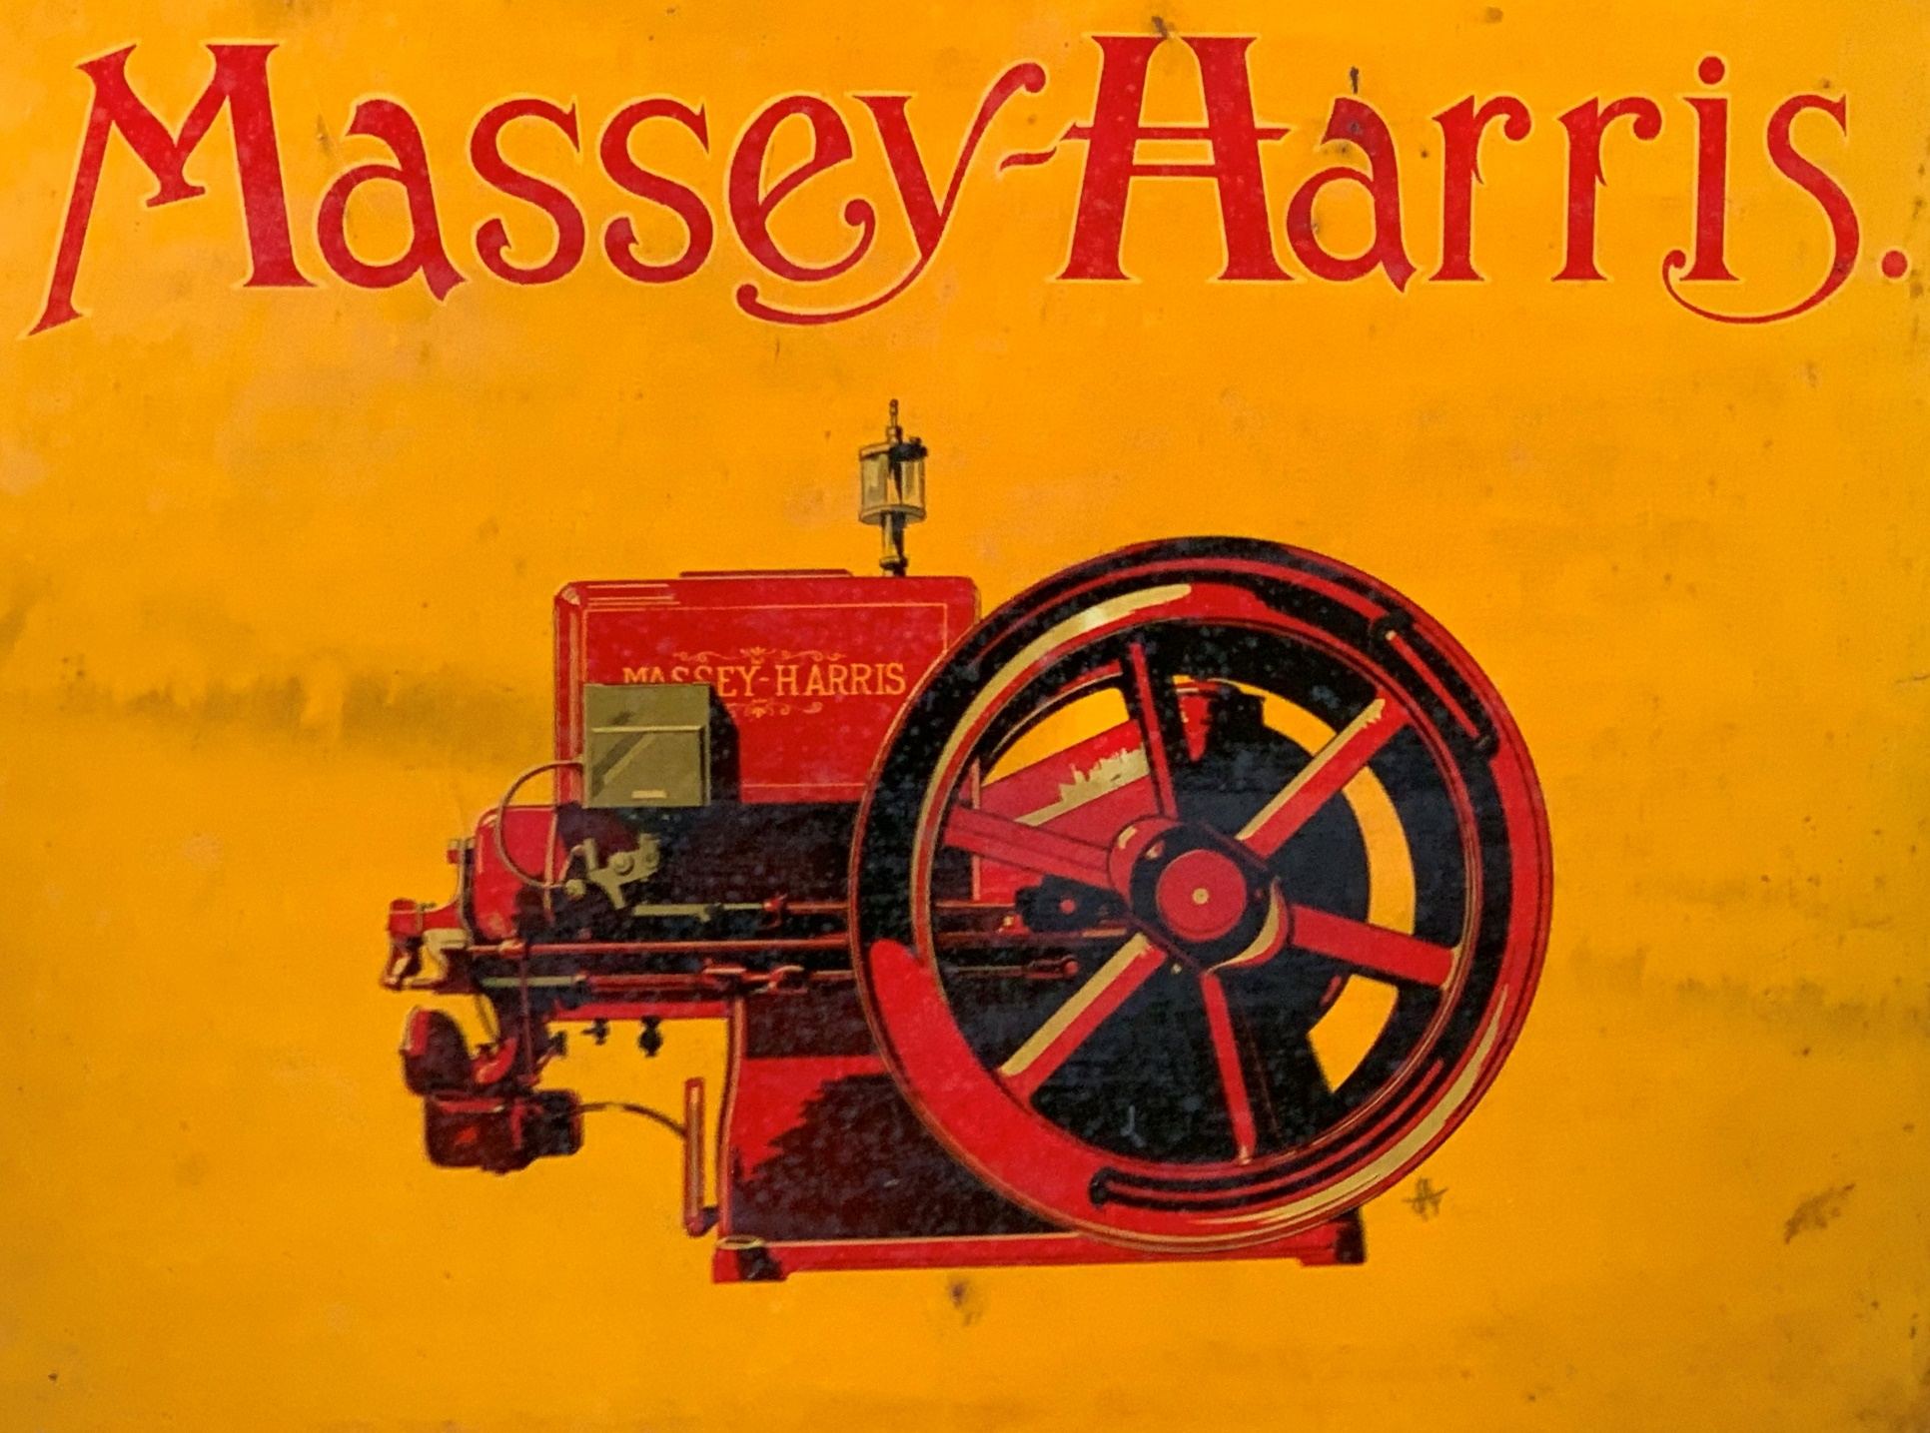

**Manufactured in Four Sizes, 1 ½ – 3 – 4 ½ and 6 Horse Power.**